Ec-2 challenge

01: Launch one EC2 instance using Amazon Linux 2
Ans: login to aws console account select ec-2 click on instance and entre details and click on launch instance
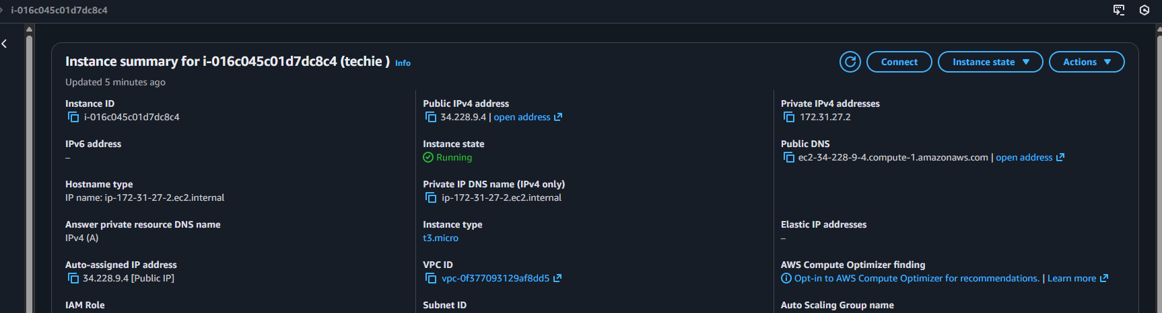

02: Install Docker.
Ans: first need to connect in server with ssh command (ssh -I privatekey.pem ec2-user@public ip) then install the docker by using command (sudo yum install docker -y) 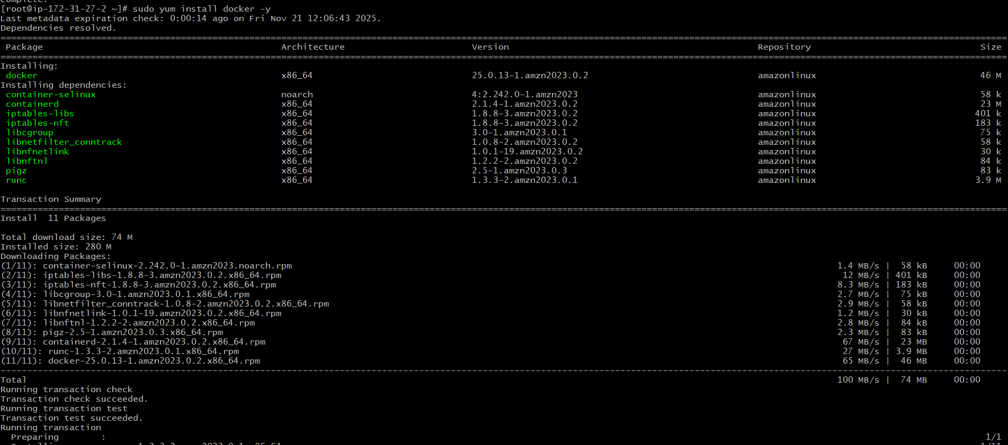
Once it get installed use command to start (systemctl start docker) then check the status (systemctl status docker) 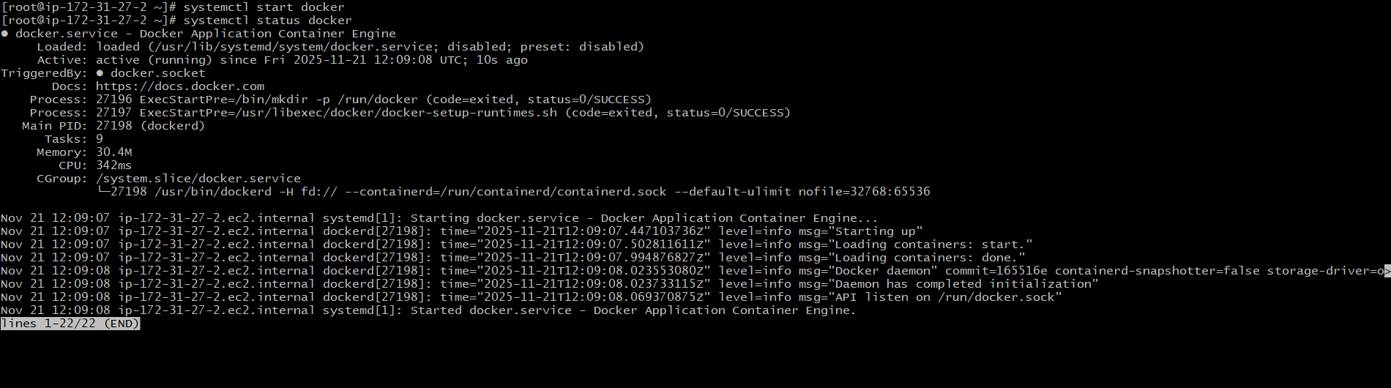

03: Install Jenkins.
Ans: To able to install jenkins first need to check the java is available or not if its not available need to install java 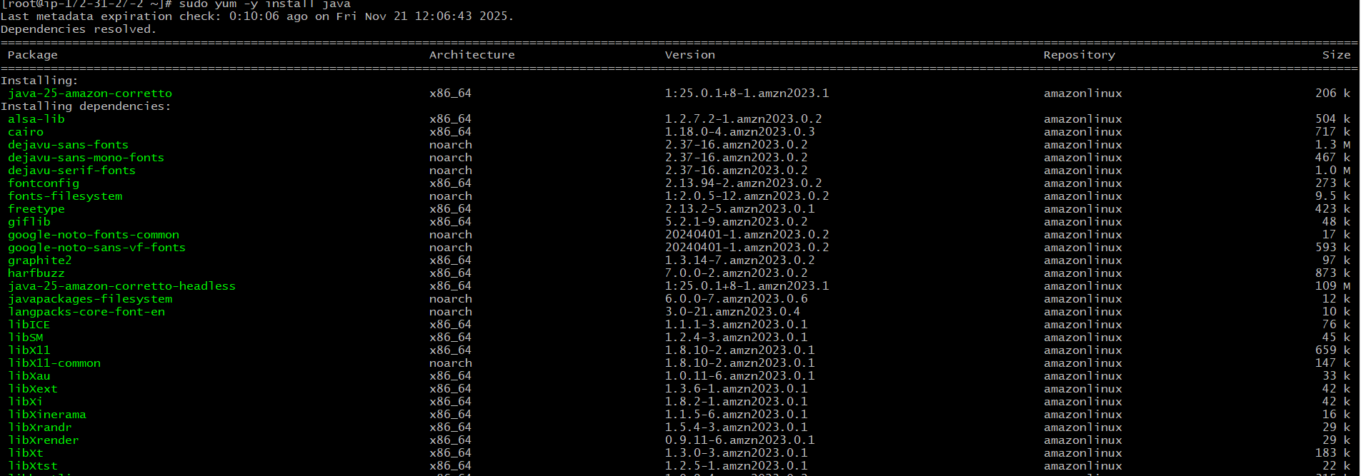cehck the version by (java -version) 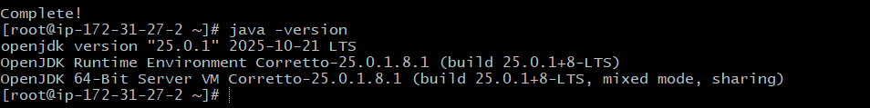
then need to install jenkins (yum install jenkins -y)
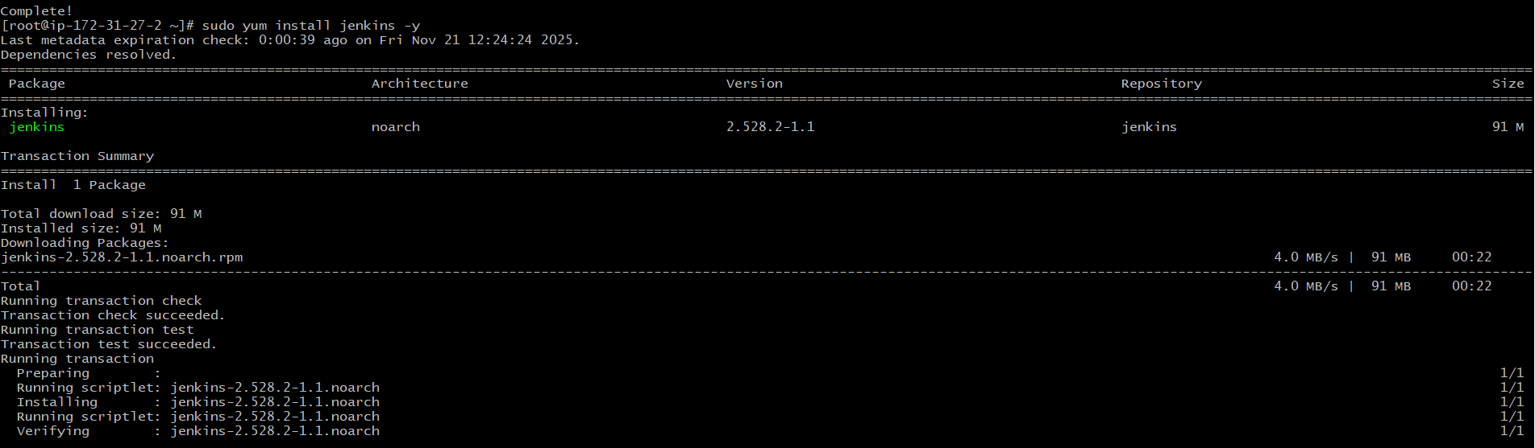
Check the status (systemctl status Jenkins) 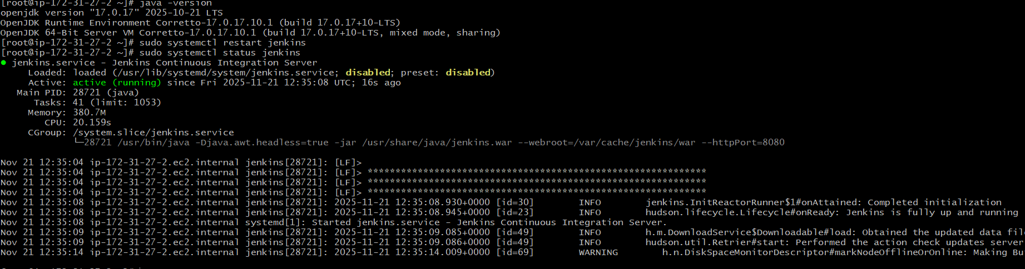
Now check in the browser with public ip and port no:8080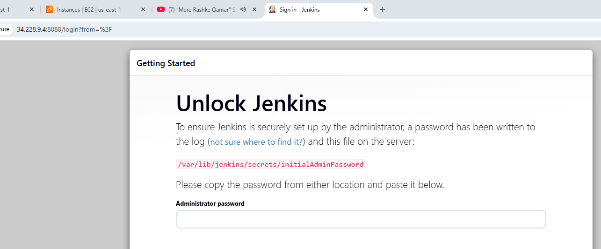

04: Install Apache.
Ans: entre the command to install apache (sudo yum install httpd -y) 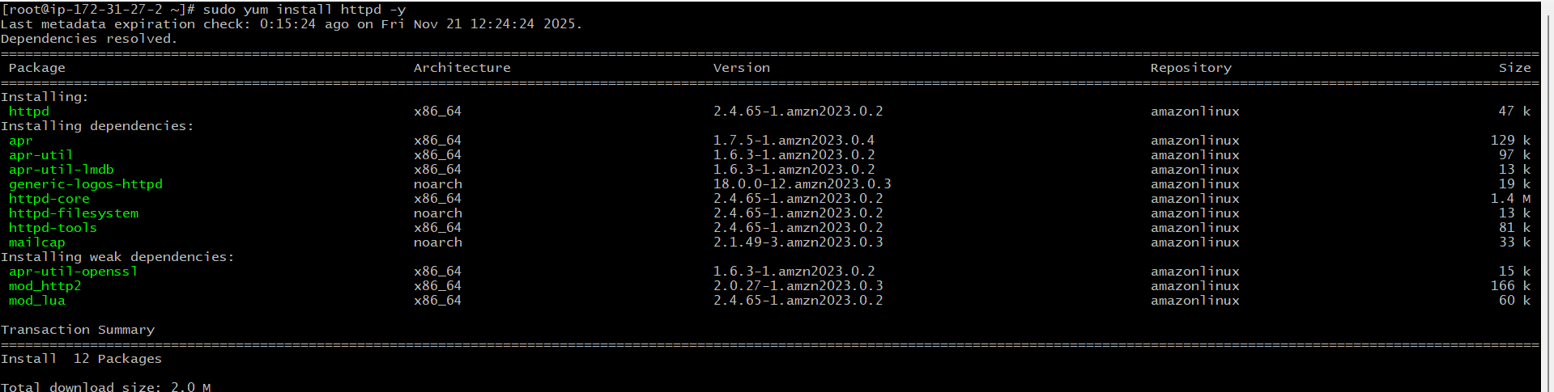
Then need to start the httpd by using command of (systemctl start httpd) and check the status (systemctl status httpd) 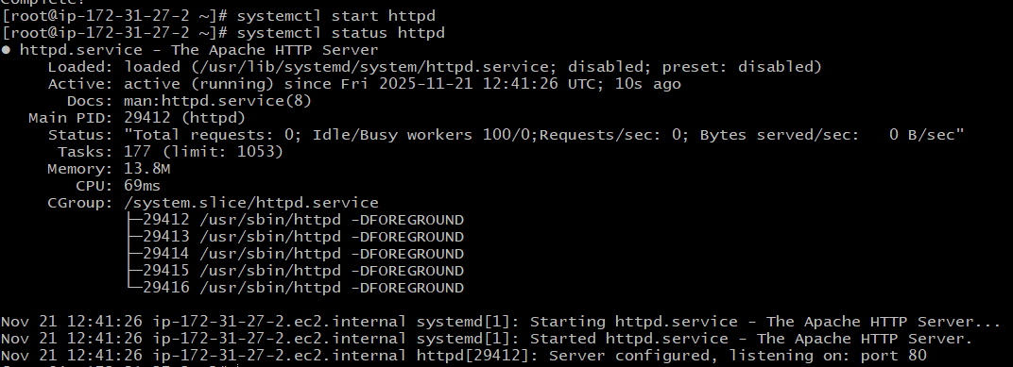
Now check in the browser with public ip and port no:81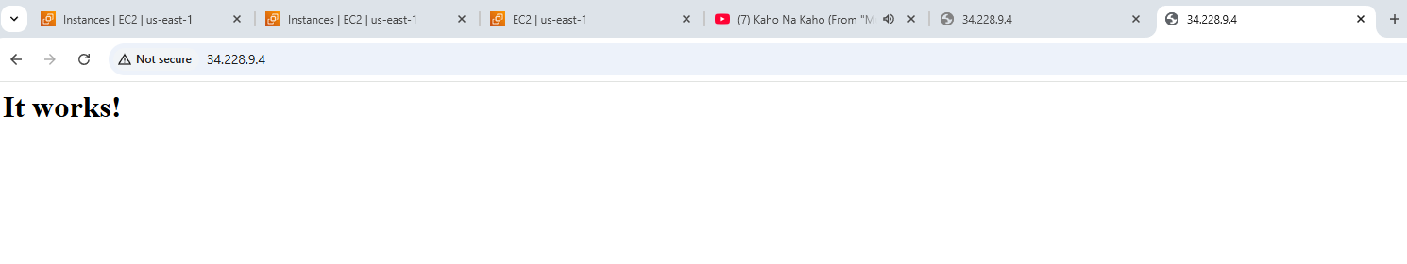
05: Install Nginx.
Ans: To install nginx run the command (sudo yum install nginx -y) 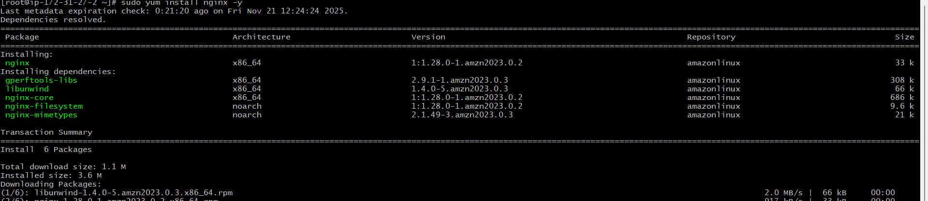
Once it get installed start nginx by using command of (systemctl start nginx)and check the status (systemctl status) 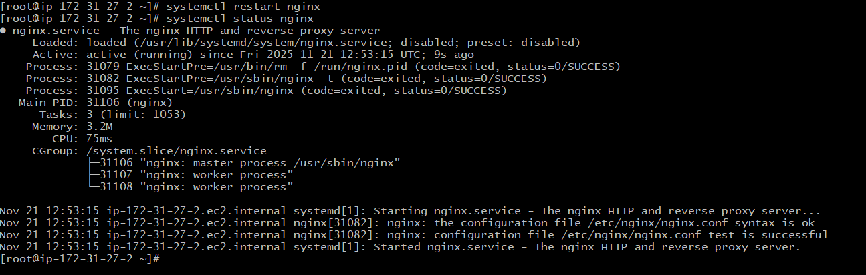
Now check in browser with public ip with port no: 80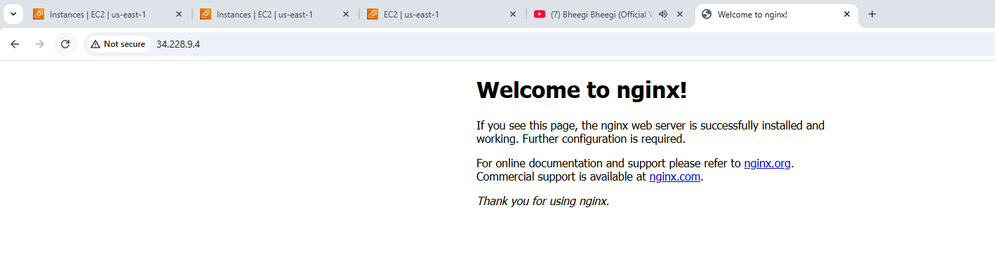

06: Install Apache Tomcat.
Ans: To able to install tomcat copy the link of tomcat and run the command in cd /opt (suo wget paste link) extract the file with (tar xzf file name )rename the file with (mv oldname newname) 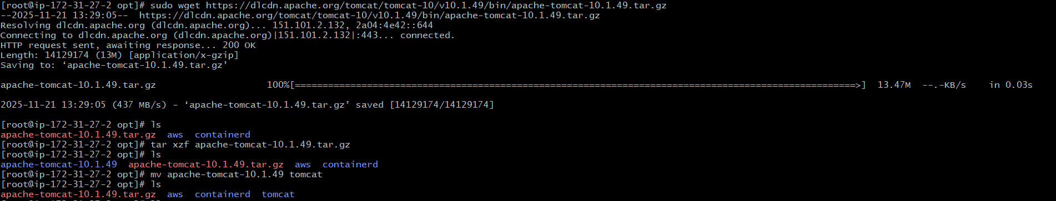
Need to create systemd service and edit the file and save need to run the file by using the command
(sudo systemctl daemon-reload)
(sudo systemctl start tomcat)
Then need to check the status by using (systemctl status tomcat) 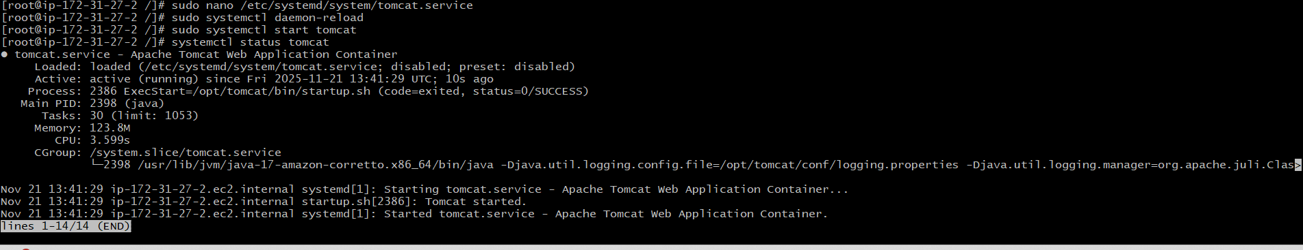
Now need to check in browser with public ip with port.no 8080
